Documentation for Owasp Report Generator (ORG)

Change log:
- 24-Sep-2006 : Initial draft – Mike

ORG Background:
ORG was initially written to solve a problem Dinis Cruz was having at a clients. He was seeing many man-hours being spent to manually deal with reports and finding no worthwhile solution he created the initial draft of ORG. This tool is made to handle all reporting and tracking tasks related to penetration tests including recording the findings of a test.

The Basics:
Step 1) Create a profile for you to use on your computer. You can do this on the first screen that will be encountered when running ORG.
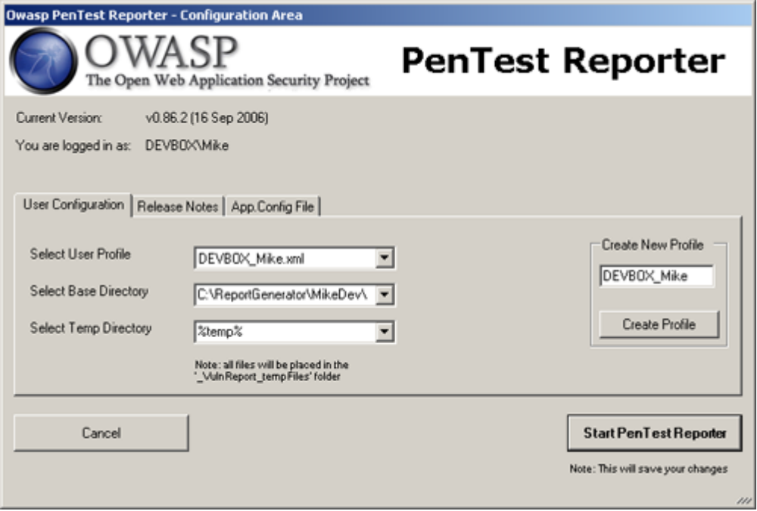
Once the information has been inputted click on “Start Pen Test Reporter” and you are ready to start adding new projects.

Step 2) The next step is to create a project. With the “Current and Archived Projects” window open make sure that the project metadata tab is selected. From there in the lower left hand corner you will see an area to type in a new project and then click “Add”. You will then see a window like the one below.
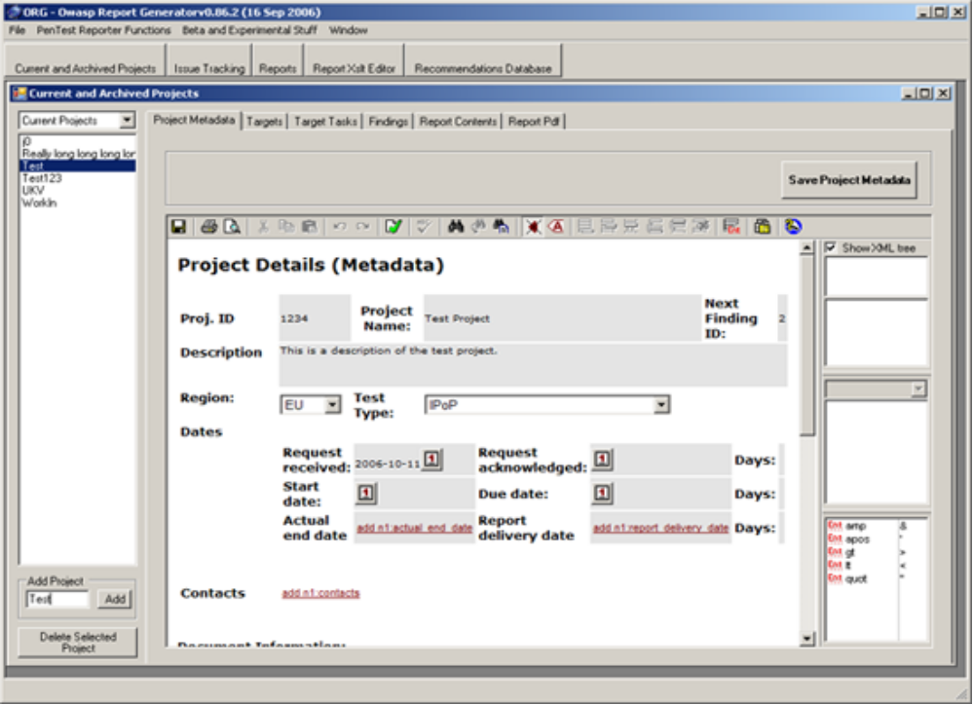You can now type in the pertinent information about your project. After that you are ready to identify your targets and start attacking (i.e. the fun part!).

Step 3) Click on the “Targets” tab and

Advance Features:
// Write the advance features area

Adding new entries into drop downs:
A user has the ability to modify the values in the drop downs in the targets, findings, project details and target tasks by modifying the any sps files under <Application_Path>/VulnReport_Files/sps/.

